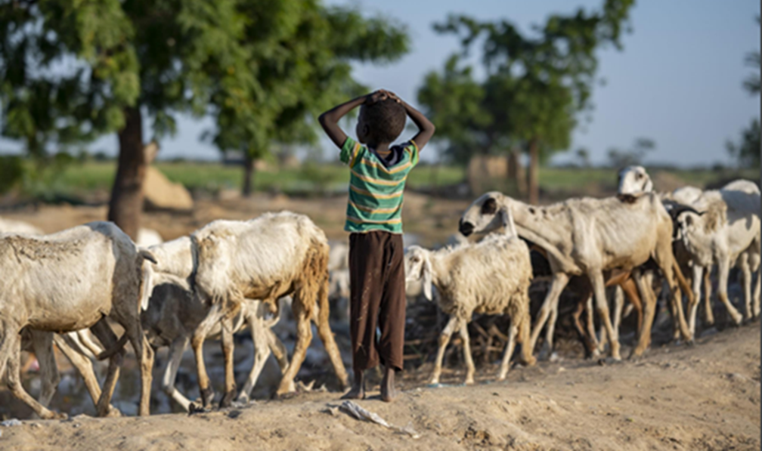
REPUBLIC OF SORAMI
Protection Analysis Update
Update on conflict and climate-related protection risks trends
DECEMBER 2022
© UNHCR / name of the photographer
Protection Analysis Update
 | Text: max. 1 page
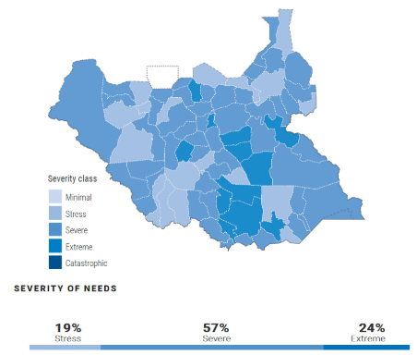
A fourth consecutive failed rainy season has pushed parts of the Republic of Sorami – ROS – to the brink of famine. Throughout 2022, severe drought, conflict, climatic shocks, and forced evictions have had a cumulatively devastating effect on the population’s coping capacities and vulnerabilities, which is escalating the impact of existing protection risks.
Since January 2022, recent conflicts in N’gurtu, Solbei, Tissura, Ateppo, Piru and other areas, coupled with unprecedented flooding in Solbei, Tissura and Piru, have only served to reverse many of the gains made through humanitarian assistance provided in 2021-22. The situation requires an upscaling of efforts to avoid catastrophic consequence in the 1st quarter of 2023.
The protection risks requiring immediate attention in the period covered by this analysis are:
- Attacks on civilians and other unlawful killings
People in Need (PiN): 200,000 (+15%)
EXTREME: 10,280 | CATASTROPHIC: 6,220
+11% | +2%
- Siege and unlawful impediments to movements
- Conflict-related gender and intimate partner violence
- Forced evictions of IDP gatherings
- Serious maiming and injuries due to explosive hazards
URGENT ACTIONS NEEDED
Urgent action is needed to stop the emerging negative coping strategies, driven by the increased food insecurity, conflict, tensions for natural resources and the unprecedented rising of abuse and exploitation that have been identified.
It is of utmost importance to:
- Ensure the timely provision of humanitarian assistance by amending the impediments caused by Law 6/42 of January 2022, and allow UNAMS dialogue and coordination for the safe passage of convoys.
- Draft a joint inter-sectoral emergency response, inclusive and sensitive to GAD, specifically targeted to strengthen the tijen, through community-based interventions, deployment of negotiation officers and multi-purpose cash support.

UPDATE ON PROTECTION RISKS SEVERITY | JUNE – DECEMBER 2022
 | MINIMAL |  | STRESS |  | SEVERE |  | EXTREME | CATASTROPHIC
 | Nara, Sarimu, West Salla, |  | Manura, Solbei, Railey, Sonrli North Salla, |  | Upper Syle,  Piru, Lombardy, South Salla, East Salla, Canna |  | Rusa, Ateppo, N’gurtu, Tailabé | Tissura, Central Syle
 | SEVERITY VARIATIONS COMPARED TO PREVIOUS ANALYSIS
 | INCREASE | 12 |  | Manura, Solbei, Railey, Sonrli, Upper Syle, Piru, Lombardy, Rusa, Ateppo, N’gurtu, Tissura, Central Syle
 | STABLE | 4 |  | Nara, Sarimu, West Salla, South Salla
 | REDUCTION | 3 |  | North Salla, East Salla, Canna, Tailabé
 |  |  |  |  |  | Text: max. 3 pages

CIVILIAN CASUALTIES |  | GBV INCIDENTS |  | IDP DROUGHTS |  | IDP CONFLICT |  | FORCED EVICTIONS
1,359 |  | 1,429 |  | 757,000 |  | 976,000 |  | 81,461
% PERIOD | % YEAR | % PERIOD | % YEAR | % PERIOD | % YEAR | % PERIOD | % YEAR | % PERIOD | % YEAR
+18% | +65% | +20% | +50% | +18% | -8% | +28% | +45% | +33% | +21%
Sorami suffered a civil war between 1978 and 1992. A peace agreement came into effect on the 2nd of March 1993, with the establishment of an initial Transitional Government of National Unity (TGNU), later replaced by an ethnic-based federalist system. Seven successful elections have taken place, characterized by a continuous change of the party in power between the National Front (NF) of Runis majority, and the Popular Front (PF) of Alemi majority. An apparent continuous political stability has characterized Sorami, but the underlying ethnic confrontations have blocked national development and important legislative processes, polarizing the existing 20 departments along the different ethnic lines. According to the Report of the Panel of Experts on Sorami, the federalist government “rather than breaking the violent cycle of elite political bargaining in Sorami, has become part of the problem, with almost all components of political endeavour now hostage to political calculations”.
Since June 2022, security and the state of protection have progressively deteriorated, due to the intensification of conflict by local armed groups. The proclamation of Law 6/42 in January 2022, which bestowed all control and oversight on budgets on the recently created Minister of Departmental Affairs, removing functions previously under the Governors of each department, has exacerbated the tensions and increased the number of armed attacks. The curfew imposed between September and October 2022 by the Popular Front (PF) currently in power, has further worsened the situation. Since January 2022, Sorami has been characterized by an active armed conflict across all its territory.
WORRYING INTENSIFICATION OF PRE-EXISTING ETHNIC RIVALRIES
Continuous inter- and intra-community tensions have been directly affecting the population in rural villages, specifically in N’gurtu, Solbei, Tissura, Ateppo and Piru. The Popular Front of Southern Sorami (PFSS), closely affiliated with the party in power and the Committees of National Unity (CNU) composed by a Runis majority, together with the ethnic groups of Talami and Araf, have been fighting for the control of territories with the acquiesce of departmental governors since 1998. First created in opposition to the federalist government, they have transitioned to governing all illicit trades, including taxation, violations, kidnapping and abduction.
The most prominent protection risks interrelated with attacks on civilians and civilian infrastructure during past escalations included: a steep increase of conflict-related sexual violence, denial of resources and services by local NSAGs at the expenses of Runis and Talami minorities, and forced child marriage and forced family separation, to specifically hinder the social fabric of rival ethnic groups.
According to the National Sorami Commission of Human Rights (NSCHR), constant human rights violations have been registered since 1998. Howver, the establishment of UNAMS, and the creation of Regional Security Committee coordinating security and protection efforts, have contributed to a downward trend in terms of victim cases not processed by the judiciary system and attacks (-15% in 2019, -20% in 2020, -25% in 2021).
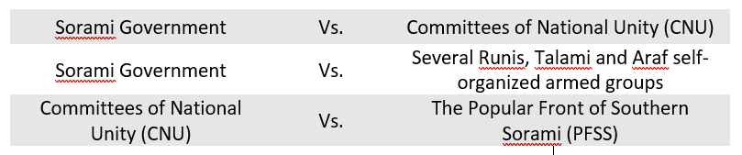
This downward trend has been fully reversed since January 2022. As of December 2021, 24 hotspot localities were identified by the Protection Cluster across the 20 departments, with an average recording of 12 injuries, 9 killings and 21 destructions of civilian buildings and looting per month. From January to June, this number increased to 75, and in the latest semester to 143. Currently, according to the ICRC, 3 armed conflicts are taking place in Sorami.
In parallel to the conflict between the Sorami Government and the CNU in Ateppo and Solbei, separate armed conflicts are taking place in other regions, especially in N’gurtu and Tissura, where Government forces are clashing with different armed groups organized locally, and including Runis, Talami and Araf minorities. Inter-communal violence in other areas of the country, for example in Piru, Solbei and Upper Syle, also remains a source of instability, displacement and human suffering since January 2022. The CNU and the PFSS are fronting various conflicts in N’gurtu, Rusa, Lombardy, Tissura and Railey.
The nature of the conflicts, mostly intercommunal violence rather than organized attacks, is having a tremendous impact on both the social fabric and overall resilience capacities, increasing the distrust and past grievances in each village and community. The Protection Cluster has observed an average of 48 incidents per month, including killing, injuries, kidnapping and conflict-related sexual violence, in Ateppo, N’gurtu, Tissura, Piru, Solbei, Central Syle, Lombardy and Railey.
These attacks root in a long-standing fight over land and resources between the Runis and Alemi, instrumentalized by the political elites specifically in the departments with highest agricultural production (Ateppo, N’gurtu) and with oil reserves and natural resources (Tissura, Piru and Solbei). In October 2022, the Institute for Peace and Development (IPD) has identified the presence of 96 self-organized armed groups, composed for an estimated total of 136,650 people (14% of which coming from the neighboring Dalistan state).
STEADY EROSION OF LIVELIHOODS AND COPING CAPACITIES.
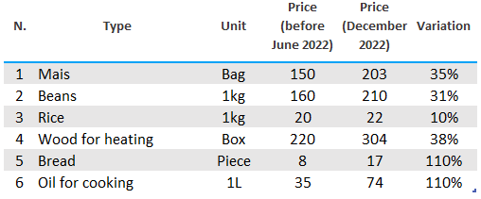
The steep resurgence of intercommunal conflicts is also increasing tensions over power-sharing, land ownership, access to resources and criminality. The impact in the last quarter is disastrous and, given the recent climate fluctuations and the impact on livelihood and agriculture, is likely to worsen. In terms of demography, a 12% increase of female-headed households has been recorded, specifically in Ateppo, N’gurtu, Tissura and Piru, and a likely increase in disabilities within the population of around 1-5% in all areas, as a result of the ongoing conflict and fighting. This is increasingly impacting the access and opportunity of women to participate in ongoing decision-making at tribal and community level, with an observed reduction in access to health and livelihood-sharing opportunities and work.
The tensions and conflicts have interrupted the access to markets, and drastically reduced income-earning opportunities, market activities and trade flows, hereby increasing the cost of life and livelihood of substantial parts of the population. Sorami is highly dependent on rain-fed agriculture and natural resources. Following three consecutive failed rainy seasons since late 2020, in June 2022 the country has faced severe drought, with more than 4 million people affected (as of November 2022) across all South Sorami.
Recent floods in November and December have compounded the situation, causing displacement, destruction of properties and natural resources. The cost of the damage caused by the floods is estimated at US$ 471 million. The most severely impacted departments are Solbei, Tissura and Piru. The effects of the lack of availability and accessibility of services are compounded by the overall inability of the population to afford related costs. Around 82% of the population is poor. Livelihoods are seriously deteriorated by conflict and climate shocks that could further lead to increased tensions between farmers and pastoralists.
It is also estimated that floods killed or displaced more than 4 million livestock (cattle, sheep, goats). In total, 2,413 km of primary, secondary, and tertiary roads were affected by floods, severely disrupting accessibility, connectivity, and the delivery of humanitarian aid. An estimated 36% of counties have one primary healthcare centre per 15,000 people while 30% one per 50,000 people. Similarly, 1,362 schools remain damaged due to flooding or conflict, resulting in insufficient and inadequate facilities. Whereas agro-pastoralism is associated with the ownership of at least three Tropical Livestock Units (TLU) per capita, equivalent to 4 cattle or 30 sheeps/goats, the current average livestock ownership is at only to 0.65 TLUs per capita. This low level is consistent with the categorization of 3.83 million being severely food insecure (IPC 3, 4 and 5). An estimated 95,000 people were classified in IPC Phase 5 in Sonrli, Upper Syle, Lombardy and N’gurtu.
WORRYING IMPACTS OF POOR GOVERNANCE AND THE DISRUPTION OF COMMUNITY FABRICS.
Government expenditures on health, education, water and sanitation, agriculture and rural development in the last 10 years have been 15% of the average expenditure of all Sorami neighboring States. State apparatus remains very weak to ensure minimum needs, let alone general well-being and security. Departmental Governors and community leaders are the only decision makers in the majority of the country.
They are major players both in ensuring security and safety and in the power-sharing balance amongst the major ethnic and political factions. Humanitarian assistance is at times the sole resource available to families, yet it is constantly challenged and impeded. Between June and December 2022, 291 humanitarian access incidents were recorded, 3 aid workers lost their lives and 232 were relocated.
Before January 2022, communities managed to cope with high levels of poverty and lack of access to governmental services thanks to the extended tijen: a cultural form of social capital and solidarity by which community leaders can exchange services and support between communities, detached from any ethnic affiliation. This form of social capital has been present in Sorami for more than 100 years and it has created an enabling environment amidst ethnic tensions.
The recent escalation, mostly due to young fighters who have less respect for this inter-ethnic pact, has disrupted this essential support and coping, specifically in Manura, Solbei, N’gurtu and Tissura. As a result, the Protection Cluster monitoring between June and December is showing the increase resort to negative coping strategies, some of which have never been registered before.
At the level of governmental policy in the given period, the Law 6/42 has cancelled all departmental focal points for the coordination of humanitarian assistance, centralizing all request and communication to the Minister of Departmental Affairs. This is currently hampering the timely provision of humanitarian assistance, expanding the governmental approvals timing from 1 day to 4-5 weeks. In addition, the Government has decided to stop the implementation of Law 312/21 on rape, amending previous legislation that equated crimes of rape and adultery, halting 10 years of negotiation. The current drafting of a decree to prohibit the freedom of assembly and rights of expression is a further issue of concern.

 |  |  | Text: max. 6 pages
 | RISK 1 | Attacks on civilians and other unlawful killings
According to the Sorami National Police (SNP), between June and December 2022, at least 2,344 people were killed, injured or kidnapped as a result of armed violence, which has included armed attacks, air and drone strikes, shelling, missile attacks and conflict-related sexual violence. The aggressions represent an increase of 18% compared to the 1,923 cases registered between January and June 2022. Men comprise the majority of victims (86% or 2,016 individuals), followed by women (10% or 234 individuals) and children as young as 5 years old (4% or 94 individuals). No socio-economic category of the population has been spared. The number of people killed and injured in 2022 exceeded by far those documented in 2020 (1,640) and 2021 (1,989). The departments most affected are Ateppo (7% or 168), N’gurtu (9% or 211), Tissura (11% or 254) and Piru (14% or 321). In these departments an average of between 7 to 13 individuals have been either killed, injured or kidnapped in the last 6 months. A total of 11 villages have been almost completely destroyed.
The areas more at risk include rural villages in the areas of Ateppo, Tissura, Upper Syle and Lombardy and IDP sites in the areas of N’gurtu, Piru, South Salla and Solbei, particularly the closest to areas controlled by the Popular Front of Southern Sorami (PFSS) and the operational commands of governmental authorities. Armed violence skyrocketed following the government’s decision to approve Law 6/42 in January 2022, which provides central control over departmental budget and funding, in an attempt to hamper the ethnic federalism created in 1992 to put at an end to the Sorami Civil War.
This decision has further exacerbated existing tensions between nomads, farmers and IDPs, among which an average 1,478 victims have been registered between 2010 and 2020. In the last three months, the farming season fell in tandem with nomads migrating their livestock, specifically in Ateppo, Tissura, Upper Syle, Piru and Solbei. Nomads often accuse farmers within IDPs groups of infringing migration routes or returning to areas where, according to them, IDPs do not originate from. IDPs accuse nomads of destroying their crops. Data from the Rural and Pastoralist network, together with the PoC monitoring show that around 1,236 hectares of cultivable land has been destroyed in the last 6 months, around 1,384 cattle killed and 11 villages destroyed.
The effects of armed attacks include direct and indirect targeting of civilian infrastructure, include specifically health and education facilities. The monitoring mechanism of the Ministry of Health and WHO has registered 65 attacks on health facilities, compared to 34 in the previous quarter. From the 1st of July, the General Directorate of National Education, together with the Education Cluster, have reported 310 burnt out classrooms, and a total of 478 incidents including harassment to children and teachers and injuries. As a result, most of the facilities have stopped functioning, preventing civilians from accessing basic services: the department of Ateppo, Tissura, Piru and South Salla do not have any working facilities, while in the rest of regions around 20% of the facilities is still running. As a result, the civilian population, which also comprises 345,581 IDPs, has been forced to move to escape attacks and due to the general insecurity. An increased demographic pressure has been registered specifically in the regions of North Salla, East Salla and Canna, due to the absence of conflict in those areas, with an average influx of 32,550 people per month during the last 3 months. This trend is particularly worrying, since it is increasing the number of unaccompanied children (no official number has yet been recorded) and it is increasing tensions in the reception areas. Particularly worrying is the possibility of extending the ethnic tensions between the Runis and the Alemi to the reception areas, where the ethnic group of the Bartai normally resides.
To mitigate violence, the Governors of Ateppo, Tissura, Piru and South Salia have unsuccessfully deployed peaceful co-existence committees, consisting of community leaders and government authorities to quell tensions and mediate disputes in hotspot locations. In the departments of Solbei, Upper Syle and N’gurtu, the recent deployment of Joint Forces consisting of RAF and RTF, in coordination with the Regional Security Committee, on the contrary, have contributed to a recent de-escalation and better dialogue between the armed groups and the humanitarian actors providing assistance.
This deployment has been coordinated with the Group of Ethnic Leaders that, at national level, has historically governed the relationships between the different groups. This has been perceived as a reaction to the rising of a local inter-ethnic self-defense group that started to challenge the ethnic leadership at local level on preserving the social cohesion and stability of the mix-villages they live in. This new trend, together with the decision of the Security Council to extend the UNAMS mandate and increase the deployment of Protection of Civilians monitors, may have positive effect on the level of violence. However, this improvement is not expected for the next semester since the departmental leaders of the armed groups have a high level of autonomy. Yet, an improvement for the second part of 2023 may be possible.

RISK 2 | Siege and unlawful impediments to movements

RISK 3 | Conflict-related gender and Intimate Partner Violence

RISK 4 | Forced evictions of IDP gatherings

RISK 5 | Serious maiming and injuries due to explosive Hazards

 |  |  |  |  | Text: max. 1 page
 |  | PROGRESS MADE ON PROTECTION
As of February 2022, 32 protection partners are responding to the protection needs of over 3 million people in need. Approximately 250,000 people (46% men, 54% women, 35% children, 9% PWD and 22% elderly) were reached in January and February 2022. 79% of persons reached are from Tissura and Piru and mainly in the major towns of Arum, Mailo, Sarwa and Sakelle, hosted in IDP sites. 80% of protection services were in GBV prevention and risk mitigation, awareness raising and MHPSS.

In December 2021 the first humanitarian explosive ordnance intervention in RSPT-controlled areas was launched as part of the HCT-coordinated response, following years of extensive negotiations. A new mine action INGO was also registered in Arum, expanding the capacities for mine action survey and clearance. The mine action response however remains critically underfunded.
 |  | ACCESS-RELATED CHALLENGES AND ACTIONS
 |  | 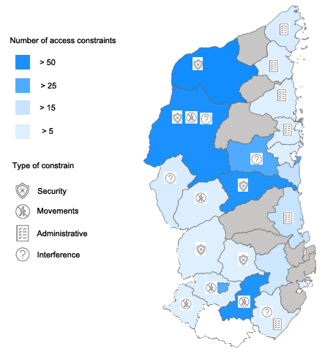 | INTERFERENCE WITH ASSISTANCE |  |  |  |  | SECURITY INCIDENTS
 |  |  | 78 |  |  |  | 47
 |  |  | +13% |  |  | +33% | -20% |  | +30%
Safety and security remain a priority concern, both at the gathering points and in areas of previous residence in Manura and Solbei. The absence of effective political efforts to address inter-communal conflicts, especially between the Runis and the Alemi, leaves the population in constant fear and insecurity, particularly in Railey, Sonrli, Upper Syle and Lombardy.
EFFORTS UNDERTAKEN TO SECURE ACCESS
NEGOTIATION WITH DUTY-BEARERS / ARMED ACTORS | 14
ADVOCACY | 3
MONITORING AND TRACKING | 7

 |  | CRITICAL GAPS IN FUNDING AND POPULATION REACHED
 |  | In December 2021 the two humanitarian explosive ordnance interventions in Mailo and Sarwa were terminated. While a new mine action INGO was registered in the area, the mine action response is critically curtailed. In the areas of Manura, Solbei, and Railey there has been a steep increase in victims of child violations, which is adding critical pressure on child protection partners. In the past months, 20% of cases were unattended. Since June, the Governors of Rusa, Ateppo and N’gurtu have introduced new regulations for the provision of assistance, including beneficiary screening and oversight of partners. Protection Clusters partners have halted operations to avoid harm to the population. The delay in CERF allocations have disrupted the child protection and GBV services in Tissura and Central Syle.
 |  |  |  |  | Text: max. 2 pages
In the period covered by this analysis, urgent action is required to stop the sudden recorded increase in abuse and exploitation. Worrying trends of conflict-related gender-based violence, and intimate partners violence need attention, as well as an escalation of efforts to stop attacks in Ateppo and N’gurtu and put a stop to the siege in Tissura and Piru. The Protection cluster and partners consider the here listed actions necessary to avoid further harmful consequences, and specifically to avoid a degeneration of the tensions between Runis and Alemi communities.
RISK 1 | Attacks on civilians and other unlawful killings
GOVERNMENT and PARTIES TO THE CONFLICT
- Stop the use of EWIPA, in line with commitments under the political declaration on EWIPA, and support the completion of a national mine action survey to capture the extent of contamination and provide information on any known contamination in the 1st and 2nd quarters of 2023.
HC and HUMANITARIAN COMMUNITY
- The erosion of livelihood and purchasing power by the population must be met with multi-sectoral initiatives to mitigate economic impacts on the population including persons with disabilities, children, and women, to avoid a worrying increase in children abuse and exploitation and trafficking in Railey, Sonrli and Upper Syle during the 2nd quarter of 2023.
RISK 2 | Siege and unlawful impediments to movements
DONORS
- Ensure all NGOs have access to the Humanitarian Exchange Facility and Humanitarian Financial Corridors, ensuring low transfer costs and securing insurance to reduce the liability of NGOs for dealing with cash by the 2nd quarter of 2023.
RISK 3 | Conflict-related gender and Intimate Partner Violence
PROTECTION SECTOR and PARTNERS
- Ensure that, in 2023, Child Safeguarding Policy training has been systematically provided for all humanitarian workers and communities to ensuring that all humanitarian actions are properly implemented to protect all children from the increasing deliberate or unintentional acts of abuse and exploitation registered in the last quarter.
RISK 4 | Forced evictions of IDP gatherings
HCT
- Identify modalities for preventing and mitigating critical protection risks associated with the forced evictions, and work constructively in creating conditions conducive for a free and voluntary process of identification of durable solutions, prioritizing the application of the Law decree 68/325 during the 1st quarter of 2023.
RISK 5 | Serious maiming and injuries due to explosive Hazards
GOVERNMENT and AUTHORITIES
- Enable Mine Action partners to deliver mine risk education efforts to various communities before the first quarter of 2023, to reduce the probability of population being victim of ordnance in Ateppo, N’gurtu, Tissura and Piru.

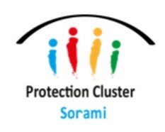

Endnotes
Methodology
Between October and November 2022, the Protection Cluster jointly with the Gender Based Violence (GBV) AoR, the Child Protection (CP) AoR and the Housing, Land and Property (HLP) AoR organized a Protection Analysis Workshop. The workshop was based on the Protection Analysis Framework and counted with the participation of 16 partners (CARITAS, UNICEF, UNHCR, UNFPA, IOM, HelpCode, OHCHR, NRC, WFP, SAMIS, Medicos del Mundos, AAM, KUSIRA, Jesuit Refugee Service, Street Child and Save the Children). The analysis has been based on both quantitative and qualitative data from existing secondary data sources, protection assessments and reports covering events from April to October 2022, including data from key country-wide protection monitoring tools – the Sorami Protection Monitoring System (SPMS), Protection and Return Monitoring Network (PRMN) and the Eviction Information Portal.
Limitations
Data available in Sorami is predominantly limited to areas that are currently accessible by humanitarian actors. Areas in Tissura, Central Syle, Rusa, and Piru, as well as areas in Manura under CNU control, are currently inaccessible to the humanitarian community. Expert judgement and a series of reflection exercises with the UNAMS and the NSCHN have been carried out for the identification of protection risks and their severity in those areas.
For further information please contact: Nur Haddad - nhaddad@unhcr.org | Giulia Piro – g.piro@prc.org

Final report Panel of Experts on Sorami, December 2021
Climate monitoring bulletin, December 2022
World Bank Global Rapid Post Disaster Damage Estimation (GRADE), November 2022
Based on the $1.90 purchasing power parity poverty line, World Bank, 2022
Floods flash appeal, OCHA, December 2022
Food Security and Nutrition Monitoring assessment, WFP, December 2022
Drought Response and Famine Prevention Plan, OCHA Sorami, December 2022
Regional governamental expenses 2012-2022, World bank
UNAMS, Trends of civilian casualties 2011-2021
HC statement on implementation of Law 6/42, March 2022.
Rural Pastoralist Network quarterly Bulletin, December 2022
DTM, December 2022.

