Introduction
This guidance note for the Joint Analysis is designed to assist Protection cluster and AoRs in conducting Cluster analysis for the Humanitarian Needs Overviews (HNOs) and subsequent Humanitarian Response Plans (HRPs).
The note explains the process for the Joint Analysis which should be carried out after the Protection Severity Scale and Protection People in Need calculations have been drafted.
Step 1: Protection & AoRs Severity Scores
Step 2: Protection & AoRs People in Need
Step 3: Protection & AoRs Joint Analysis

Figure 1: Visual representation of the process

Protection Joint Analysis
During the data analysis stage of the HNO, Severity ranking, and People in Need calculations are completed and presented as a draft for endorsement. During the Joint Analysis phase, the Protection, AoRs partners and stakeholders work on the review of the results and findings coming from the data analysis. These results are finally endorsed based on the discussions / group work carried out during the Joint Analysis stage.
The Joint Analysis process can follow several formats such as meetings, webinars or workshop setting depending upon the context.

Objective
The main objective of a joint analysis exercise is to secure a consensus on the Severity ranking, People in Need (PiN) figures, priority protection threats etc. The inclusion and participation of Protection actors’ partners and stakeholders in this process is critical.

Joint Analysis Process
Cluster and AoRs should have finalized the draft Severity ranking, PiN, priority threats etc. before organizing a joint analysis session. Protection Cluster and AoRs can choose to either host a one joint session or alternately separate sessions with their constituencies.
A joint session on analysis by Protection cluster and the AoRs will send out a message of collaboration and cooperation on the protection analysis.
In the case of AoRs convening their own joint analysis sessions with their constituencies, it is recommended that it happens after the joint analysis session for Protection Cluster has been finalized. This will ensure if overarching severity and PiN is modified and threats are reviewed, AoRs can take that into account during their joint analysis workshop(s).

Workshop Modality
The Joint Analysis workshops can either be organized, first at the sub-national level. Subsequently, the results of these workshops can feed into the final national level joint analysis session or workshop. This modality will ensure the buy in, participation and inclusion of national and local partners and stakeholders in the process.
Alternately, the teams on ground can only have a single national level joint analysis workshop. This option is only recommended when the country of operation is in the first phase of the emergency (i.e., during the first 3 months), there are very limited number of protection partners and stakeholders or the humanitarian access is restricted.

Profile of the workshop participants
The constituency varies from country to country, and it is the responsibility of the coordinators to decide about the total number and profile of the participants.
The profile of participants in the joint analysis sessions can be summarized as “the full constituency of Protection and AoRs partners and key stakeholders”.
Some examples of constituencies are: National and local authorities; national and local partners; National and local NGO forums; International partners; Information Management WGs, OCHA, donors or other clusters, especially if protection is seeking to reinforce and foster Protection mainstreaming and integrated approaches.

Joint analysis session dynamics
1) During the joint analysis session, Protection Cluster and AoRs can provide an overview of the following to the participants:
- HPC process and the timeline,
- selection and use of indicators,
- identified protection threats,
- selection of the PiN % for each of the population groups,
- internal analysis process,
- interaction with other clusters, OCHA etc.
2) Review in plenary the finalized severity ranking by each geographical unit of analysis explaining the process and the initial ranking and the identified protection threats.
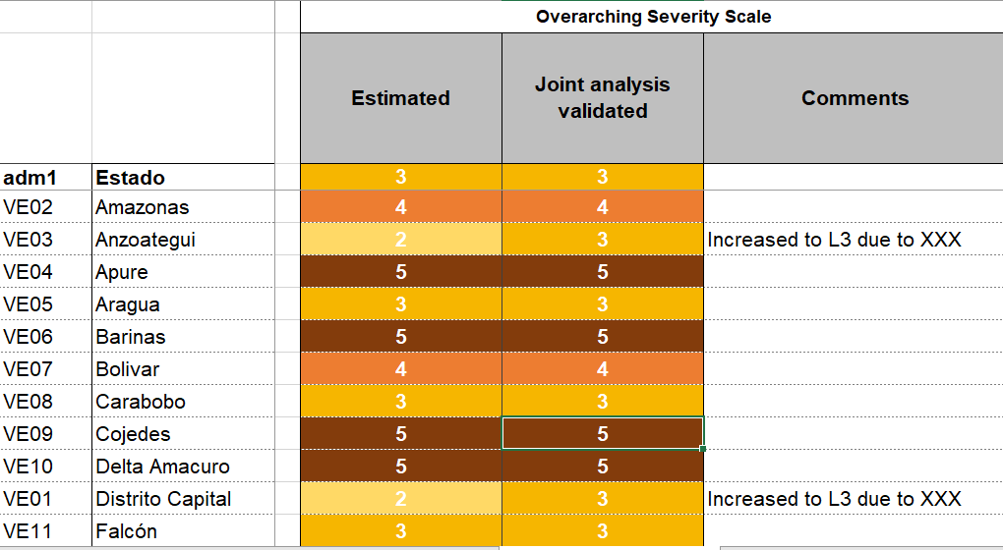
After discussion, participants will either endorse or review the severity as shown in this example from 2019 HNO for Venezuela:
Figure 2: Severity ranking validation for 2019 Venezuela HNO
If after discussion there is consensus on the ranking, the participants can move to the next geographical unit of analysis and repeat the process of endorsement. The process will continue until all the geographical units have been reviewed and their severity ranking endorsed.
In case of disagreement, the severity ranking of the unit of analysis should be discussed in a plenary session. The ranking review can result in either an increase or decrease of the severity ranking of the unit of analysis. Any change in severity ranking should be supported by:
- Contextual knowledge or update. National and local actors can play a key role in this regard together with the roll out of sub-national joint analysis sessions.
- Additional data/information regarding the specific geographical unit of analysis (i.e., presence/lack of unreported armed groups, recent return / displacement of population etc.)
- Confirmed presence/ or lack of a protection threat in the area.
Please keep in mind that changes in the severity ranking will have a direct impact on the PiN estimates. If the ranking increases or decreases after the joint analysis sessions; the % of PiN should change accordingly for that unit of analysis.
The final outcomes of the joint analysis are a final severity ranking, update to PiN figures (if required) and priority Protection threats. These outcomes will have direct linkages with the HRP in terms of Protection Strategic and sectoral objectives, priority areas and groups, targeting and overall response strategy.

Support request
If you encounter any challenge or difficulty at the field level, please get in touch with us:
Region | HPC Regional Coordination Focal Point | HPC Regional IM Focal Point
Asia/Pacific/Europe | David Winiger, winiger@unhcr.org | Kashif Rehman, rehmanka@unhcr.org
East & Southern Africa | Jessica Gorham, gorham@unfpa.org | Kashif Rehman, rehmanka@unhcr.org
Latin & Central America | Boris Aristin, aristing@unhcr.org | Boris Aristin, aristing@unhcr.org
MENA | Julien MARNEFFE,  marneffe@unhcr.org | Kashif Rehman, rehmanka@unhcr.org
West & Central Africa | Noemi Dalmonte, dozin@unhcr.org | Boris Aristin, aristing@unhcr.org

