 Referral Pathway Guidance Note
Protection Cluster, Cabo Delgado

A referral is the process of directing a client to another service provider because s/he requires help that is beyond the expertise or scope of work of the current service provider/organization. A referral can be made to a variety of services, for example health, psychosocial activities, protection services, nutrition, education, shelter, material or financial assistance, physical rehabilitation, community centre and/ or a social service agency. However, it is preferred that, if possible, the referral is made to a case management services as such services are ‘entry points’ for specific types of cases (e.g GBV, child protection, protection, MHPSS, etc.) and are responsible for connecting the case with other services in the referral pathway as needed and desired by the case.

Guiding Principles

In order to safely and timely refer cases and avoiding causing harm to the individual/community in need of assistance, the referral needs to respect at all times the following principles:

- Confidentiality: The principle of confidentiality requires all interlocutors to protect information disclosed or gathered in relation to any individual and to ensure that information is made accessible to a third party (i.e. service providers) only with the individual’s explicit informed consent. This includes ensuring that collecting, storing and sharing information on individual cases is conducted in a safe way and according to agreed-upon data protection policies.

- Consent: Referrals should only take place once the individual has given their informed consent. The individual has the right to limit information s/he wishes to disclose and persons with whom information will be shared. In the case of children the informed consent of the caregiver should also be sought for the referral.

- Respect: Your role as staff, partner or volunteer is to provide information about services available, in order for them to make a free and informed choice. Under no circumstances should you give counselling or put pressure on the individual to access one or other services. Respect their dignity, decision- making capacities and preferences. You are not supposed to express your opinion, pass judgment or blame the individual.

- No false expectations: Only share information if, based on service mapping, the services exist/are available. Staff or volunteers of the referring agency cannot guarantee access to the services or the results or quality of the service, and this needs to be explained to beneficiaries. However, it should also be explained that in case of any problem accessing the services, individuals requesting referrals can come back to inform referring agency staff or volunteers and can ask for additional support.

- Safety and security: Organizations’ staff must take actions to ensure the physical and emotional safety of individuals who have experienced or are at risk of violence, abuse, exploitation or neglect. The physical safety of the individual should be prioritized above all other actions or referrals that may be available. Safety and security considerations should also be taken into account when presenting referral options to an individual, to the extent that frontline staff can reasonably be expected to be aware of relevant risks.

Referral Channel

The referral form is intended to be used by humanitarian organizations as a tool to facilitate inter-agency referrals, and as a means to document referrals in accordance with minimum standards. The flowchart below indicates a summary of the referral process for individual cases identified in need of assistance:

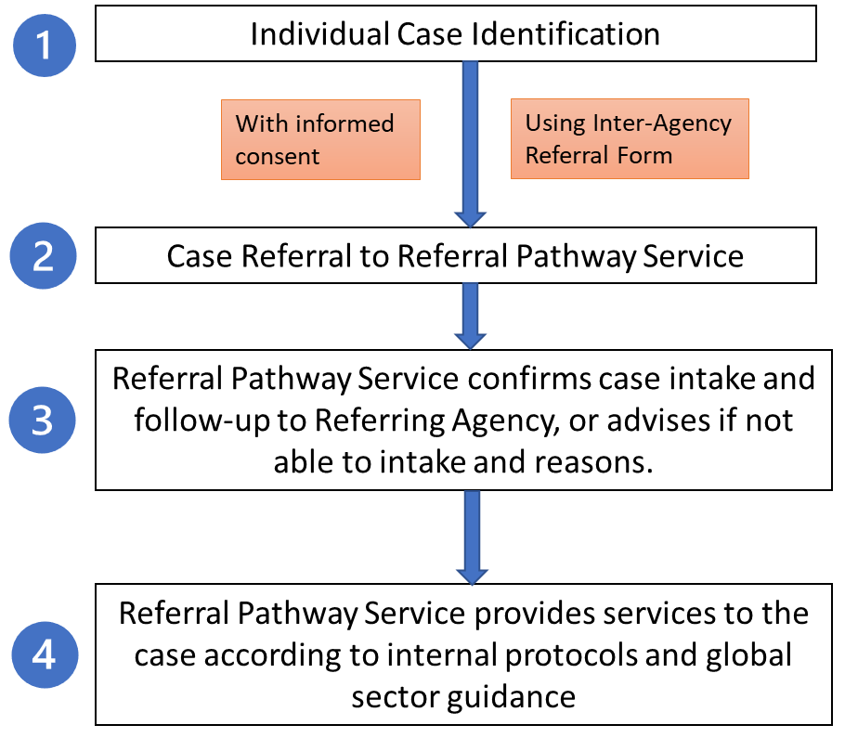

The referrals should be made to the identified services in the site/location-based service map using the contact information and intake criteria provided. It is essential that each sector lead is responsible for coordinating with the service providers of their specific sector to ensure that service mapping information remains up to date and accessible to all humanitarian actors at central and field level. In locations/situations whereby a specific sector services is not available, the organization that has identified the case should seek guidance from the relevant sector lead to understand how to proceed based on global guidance/support available.

Methodologies

In general circumstances, the steps required to make a successful referral are:

- Identify the problem and/or rapidly assess the cases problems and needs (note this should not be an in-depth technical assessment as this would be conducted by the relevant sector upon referral);
- Identify which organization or agency can meet this need;
- Contact the service provider to confirm eligibility and availability of services;
- Explain referral to the case, including detailed information on the types of services available, location of service providers and contact details;
- Document consent. If the client agrees to the referral, obtain consent before the client’s information is shared with others and agree with the case, which information can be shared;
- Make the referral. Fill out the inter-agency referral form (it is advised that the original copy is provided to the service provider upon referral and it the referring agency wishes they may take a copy for their records until the referral and follow-up is confirmed by the service provider at which time the referring agency should safely destroy their copy of the referral form);
- Follow up with the case and the receiving agency to ensure the referral was successful and exchange information, where case consent allows for this. Areas for follow up include: did the case receive the planned services? What was the outcome? Was the case satisfied with the referral process, and the services received?
- Maintain confidentiality. All referrals forms and case files should be stored in secure environment to ensure the implementation of safe and ethical data collection, management and storage of information. Once referrals are made and effectively followed up then the referring agency should safely destroy the referral form.

Monitoring

The success of an inter-agency referral system could be tracked using a variety of indicators, depending on the agencies’ data and reporting needs. In the context of the Protection Cluster, Cabo Delgado, a unified reporting template can be used as a format to collect fundamental information of each case. The data collected through a harmonized approach will not only facilitate necessary assessment of the overall referral system. It will also allow the Sector to conduct proper studies on best practices and concurring gaps in services for further discussion across sectors. It is recommended that each agency and sector maintain a data base of referrals, with de-identified non sensitive data in order to monitor the referral process in practice.

Sources:

Inter-Agency Referral Form and Guidance Note, Inter-Agency Reference Group for Mental Health and Psychosocial Support in Emergency Settings, 2017 Guidance Note for Inter-Agency Referral Form, Protection Cluster, Yemen, 2017

See Annex 1: Inter-Agency Referral Form
See Annex 2: Inter-Agency Referral Services Map Template
See Annex 3: Referral Data Collection Template

